**ДЕМОВЕРСИЯ**

**итоговой контрольной работы по предмету «Английский язык»**

**за курс 5 класса**

**базовый уровень**

**Аудирование**

**Задание 1.**

|  |
| --- |
| Вы услышите 6 высказываний о семье Баркеров. Соотнесите содержание утверждений с именами членов семьи. Вы услышите запись дважды. |

1. **John a)** enjoyed his morning sleep
2. **Sally b)** listened to music
3. **Margaret c)**watched the news on television
4. **Richard d)** washed the plates after breakfast
5. **George e)** worked in the garage
6. **Chase f)** played football with some friends
7. **Smokey g)** joined Sally in the kitchen

|  |  |  |  |  |  |  |  |
| --- | --- | --- | --- | --- | --- | --- | --- |
| Speaker | 1 | 2 | 3 | 4 | 5 | 6 | 7 |
| Name |  |  |  |  |  |  |  |

**Лексика и грамматика**

**Задание 2.**

|  |
| --- |
| Прочитайте приведённые ниже предложения. Выберите подходящие по смыслу слова, так, чтобы они лексически и грамматически соответствовали содержанию предложений. Обведи букву правильного ответа. |

4. Lake Baikal is ………… lake in the world.

a) the deepest b) deep c) deeper

5. …….. are they famous for?

a) Where b) What c) Who

6. People watch television and spend time together in the …………. .

a) bathroom b) dishwasher c) living room

7. Last Sunday Jane ………. with her friends in the park.

a) walked b) is walking c) will walk

8. Rose …….. the airport is situated outside the city.

a) stays b) tells c) says

9. Mark …… play football.

a) doesn’t b) isn’t c) don’t

10. You ….. visit the museum today. It’s closed on Mondays.

a) mustn’t b) can’t c) can

11. James …… to go to the shops tomorrow.

a) is going b) are going c) going

12. Kate and Pam …… on the farm when they were children.

a) live b) lived c) can live

13. David Beckham is one of the …… footballers in the world.

a) most popular b) more popular c) popular

14. What is there …… the bridge?

a) across b) between c) among

15. Little kittens and ……. are very cute.

a) watch b) puppies c) oceans

**Чтение**

**Задание 4.**

|  |
| --- |
| Прочитайте внимательно текст и отметьте утверждения 1-10 **T** (true)/ **F** (false)/ **NS** (Not Stated) |

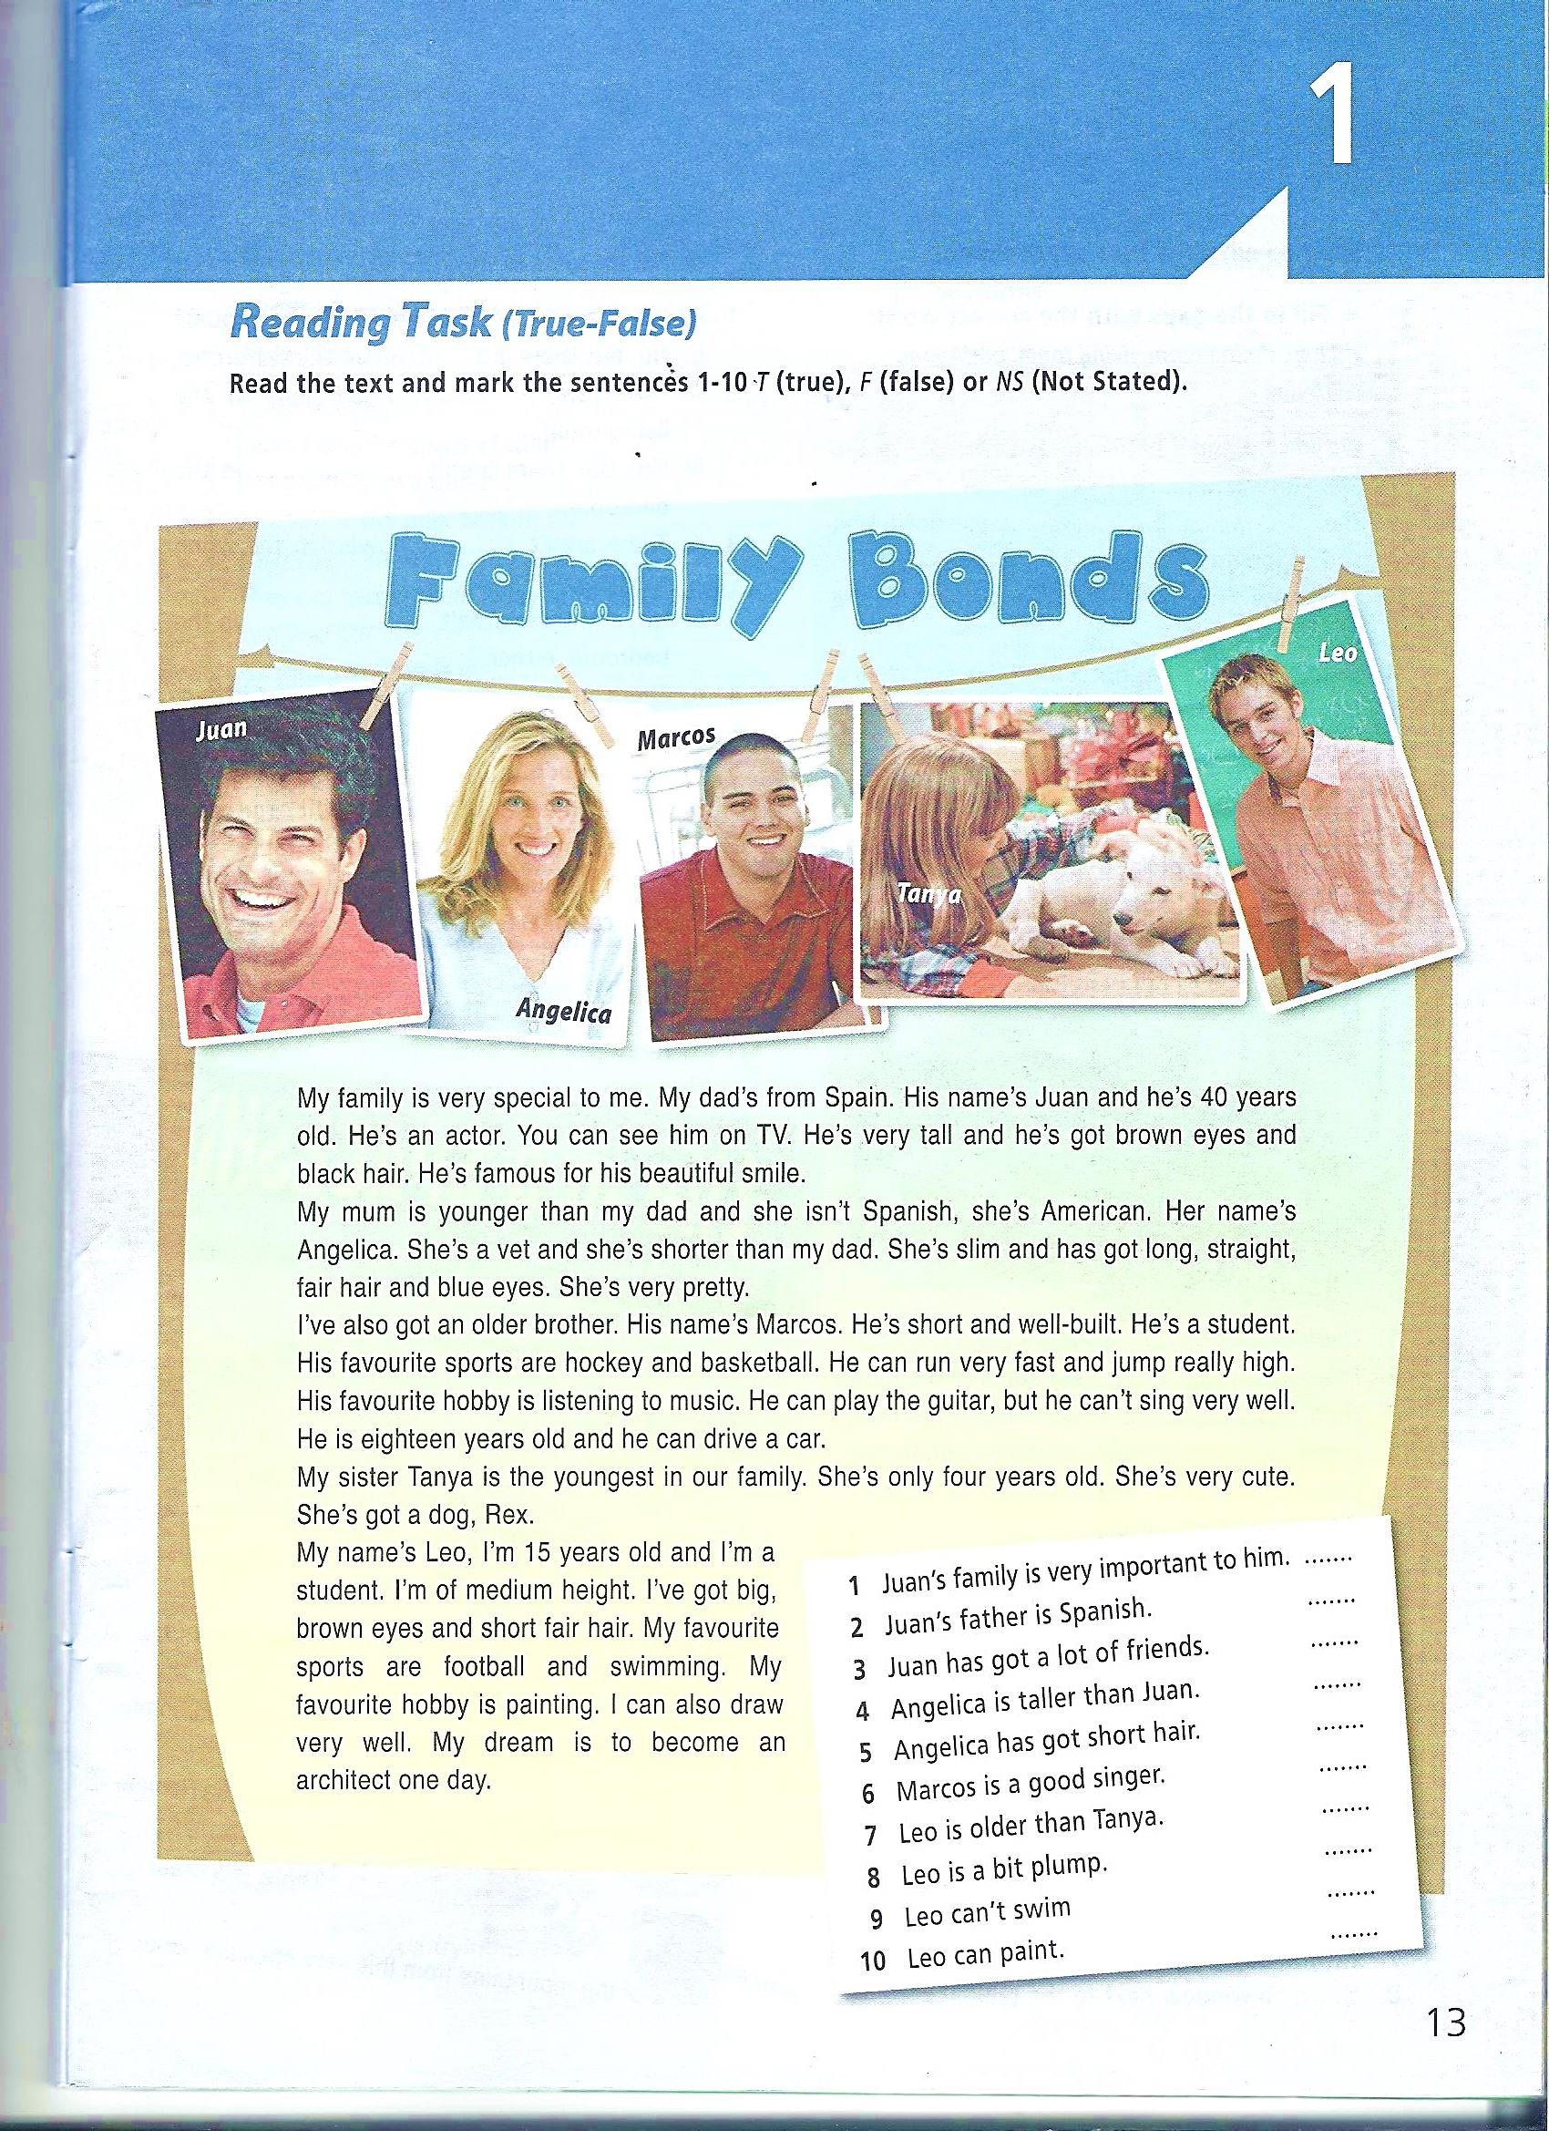

**Письмо**

**Задание 5.**

|  |
| --- |
| Ответьте на вопросы. Ваш ответ должен быть полным и развернутым. |

1. **Where do you usually travel? _______________________________________________________**
2. **Do you like travelling by car, by plane or by train? _____________________________________**
3. **What hobbies do you have? _________________________________________________________**
4. **What animal is the best pet? Why?___________________________________________________**

**_________________________________________________________________________________**

1. **Why do people go to museums? _____________________________________________________**

**_________________________________________________________________________________**