**ДЕМОВЕРСИЯ**

**итоговой контрольной работы по предмету «Английский язык»**

**за курс 6 класса**

**углубленный уровень**

**1. Аудирование.**

|  |
| --- |
| Вы услышите аудио запись о туристическом автобусе. В заданиях **1 – 5** выберите **True (T)** или **False (F)** . Вы услышите запись дважды. |

1. Passengers with tickets for the sightseeing bus can do the tour over two days. **True False**

2. The bus changes its route on Thursdays. **True False**

3. The city hall is a music venue. **True False**

4. The bus route connects with a ferry terminal. **True False**

5. Green Park is in a central location. **True False**

**2. Лексика**

|  |
| --- |
| Прочитайте приведенные ниже предложения. Выберите подходящие по смыслу так, чтобы они грамматически соответствовали содержанию предложений. Обведите букву правильного ответа. |

6. London ……. millions of tourists every year. A) buy B) orders C) attracts

7. Heat the oil and …..the mushrooms for 10 minutes. A) drink B) fry C) fail into

8. Christopher Columbus made four …….. to America. A) voyages B) legends C) empires

9. My mum …… me to become a volunteer at the local zoo. A) spent B) encouraged C) took

10. Don’t swim in the lake; it’s very …… A) hunting B) nasty C) polluted

11. Many dinosaur …… were found in South America. A) chariots B) fossils C) reign

12. The restaurant serves ……. French food. A) antique B) replica C) authentic

13. The ……. of our trip was visiting an ancient fort. A) highlight B) twilight C) inspiration

**3. Грамматика**

|  |
| --- |
| Прочитайте приведенный ниже письмо. Закончите текст, используя глаголы в скобках в нужном времени. |

Dear Sally,

I 14)………….( write) to you from Miami. We 15)………….(be) here for ten days and we 16) ………(like) it very much. We 17)…………(stay) at a wonderful hotel by the beach.

We 18) …………. (already/ visit) a lot of interesting places. Yesterday we 19)………..( go) to Disneyworld! We 20)………(have) a great time and we 21)………(buy) a lot of souvenirs for everyone at home. Mum and Dad 22)….. (take) us to the Epcot Center tomorrow. It’s an amusement park and it’s got lots of spaceships.

We 23) ………. (usually/ spend) the morning on the beach. The sea 24)……(be) warm and clear. Dad 25)………(try) to windsurf for the first time yesterday, but he 26)……….(not/have) a good time because he 27)…….. (keep) falling into the water.

That’s all our news. I 28) ……. (hope) you’re well. See you soon.

Love,

Mary

**4. Чтение.**

|  |
| --- |
| Прочитайте текст. Выберите один правильный вариант ответа из 4-х предложенных A, B, C, D. |

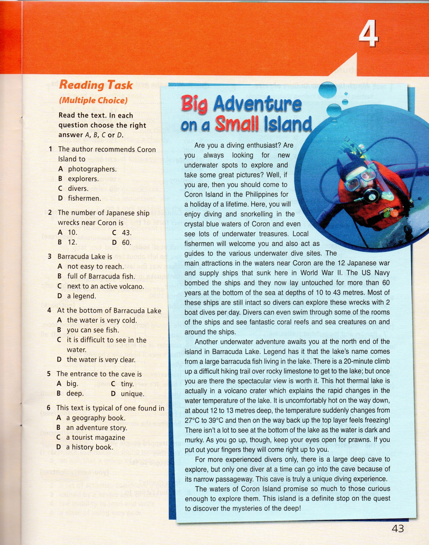

34

33

32

31

30

29

**5. Письмо**

**35)** Imagine you are on an adventure holiday in South America. Write an email to your English- speaking pen friend, Kelly, telling her about it (80-100 words). Mention:

* Where you are
* What you are going to visit
* What holiday activity you are going to see/ do there